Magazine focus: **Trendy Food Spots in California**

Pinterest board: <https://pin.it/4W3fjSK>

Tasks

1. Write an introduction to your magazine, with its name and its focus.

* *Taste: Southern California* is a monthly American food and entertaining magazine that typically contains entertaining ideas, restaurant recommendations of trendy food spots within Southern California. Food impacts all areas of our life from health and finances to travel and family as well as our social lives. The focus of our magazine is to inspire and encourage discovery by showcasing the most popular spots to dine in at.

1. Choose 3-8 words that you would associate with your brand voice.
   1. Clean
   2. Fun
   3. Modern
   4. Minimalistic
   5. Calm
   6. Cultured
2. Generate a preliminary color palette on Coolors or any similar service with shareable links for specific themes.
   1. 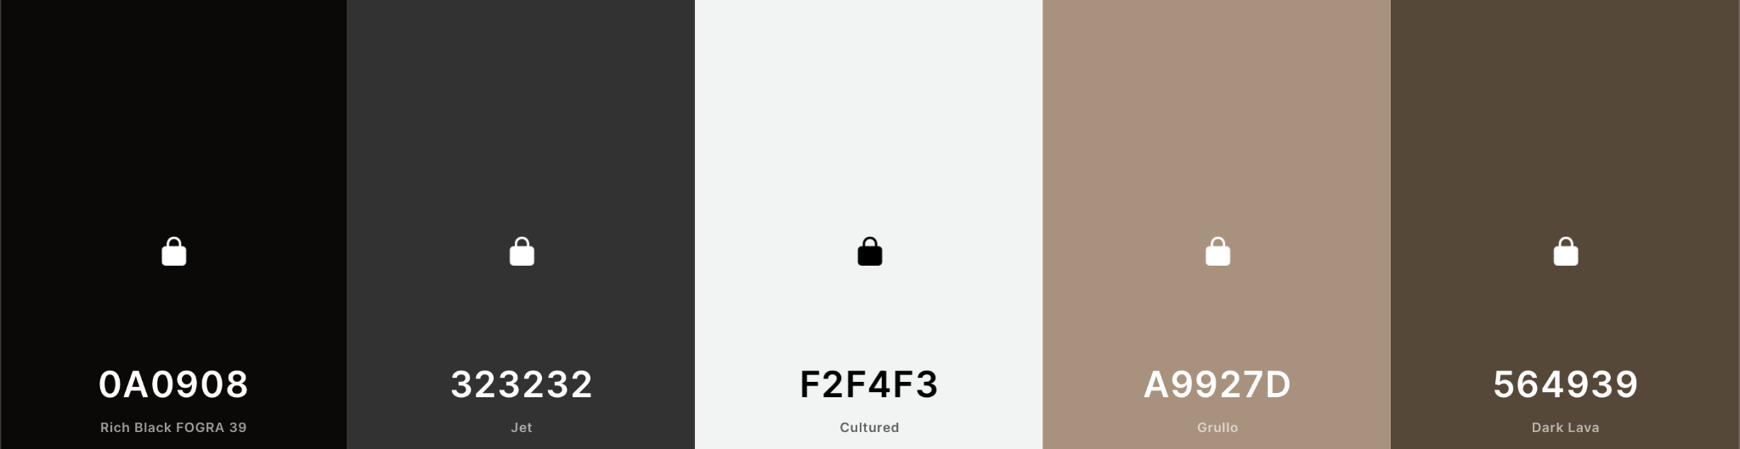

| 0A0908 | 323232 | F2F4F3 | A9927D | 564939 |
| --- | --- | --- | --- | --- |

* 1. <https://coolors.co/0a0908-323232-f2f4f3-a9927d-564939>

1. Choose two or three type families from Adobe Fonts for your publication.
   1. Brandon Grotesque (<https://fonts.adobe.com/fonts/brandon-grotesque>)
   2. Mr Eaves Sans (<https://fonts.adobe.com/fonts/mr-eaves-sans>)
   3. Buffet Script (<https://fonts.adobe.com/fonts/buffet-script>)
2. Download this template and populate it with the content of your proposal.

